Level 1 USG Support Document

Table of Contents
USG Overview 4
Connecting to the USG 5
Subscriber Administration 6
View Current Users 6
Add a User 7
Find a User or User Name 13
Change a User from a Private IP to a Public IP 14
Verify Time Left on a User’s Account 16
Add Time to a User’s Account 17
User Does Not Get Public IP Address After Purchase 19
IP Upsell 21
Configuration 22
Verify If the USG Has SMTP Redirection 22
Homepage Redirection 23
Pass Through Addresses 24
Port Location 25
Change the Status of a Port 25
Find a Port Mapping 27
Error Messages 28
This Field Must Contain a Number Between These Two Values; ; 1,1 28
The Promotional Code You Have Entered is not Correct. Please Try Again. 28
USG Blocked Subscriber Access 28
The User ID You Have Entered Cannot be Found. Please Try Another. 28
The Password Field You Have Entered Is Not Correct. Please Try Another. 28
Error in Room Billing 28
Portal Screens 29
Free Access 29
Wired with Access Codes – Billing 31
Wireless Only – Billing 34
Credit Card – Billing 35

USG Overview

The Universal Subscriber Gateway II (USG II) is a stand alone, high performance networking device designed for developing large scale, intelligent Public-access networks for mobile computer users. The USG II enables the rapid rollout of broadband Internet access for up to 2,000 simultaneous users—regardless of whether the broadband network is wireless, DSL, cable, or Ethernet. The back on the device has two 10/100 Ethernet ports (one for network and one for subscriber) and 2 serial ports (one for PMS billing and one for management).

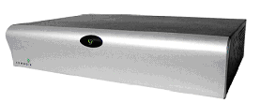
Figure 1 - USG Front View

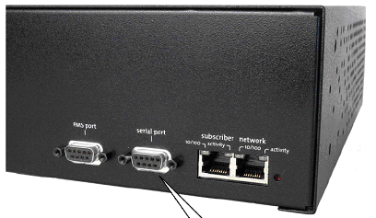
Figure 2 USG Back View

Connecting to the USG

To connect to the USG with a web browser, the URL is http://<IP address of USG>. An example would be http://12.159.210.2.

After connecting to the page, you have to login with a username and password. After logging in, you should receive the following screen.

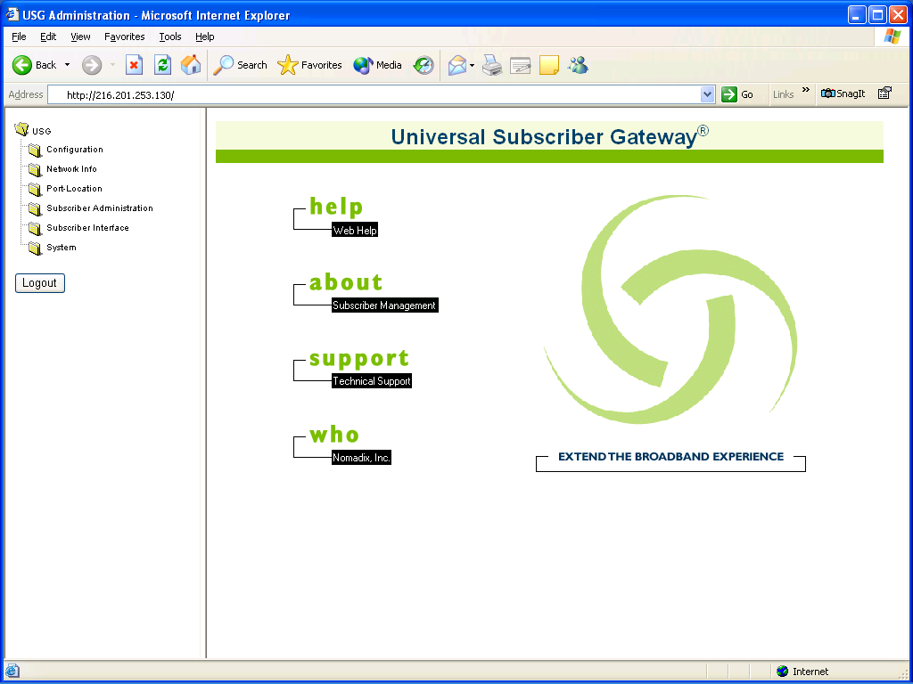

Subscriber Administration

This section allows you to view current subscribers and inactive subscribers.

View Current Users

This section allows you to view all currently connected users.

Select Subscriber Administration, Current from the left menu. You should receive a screen similar to below:

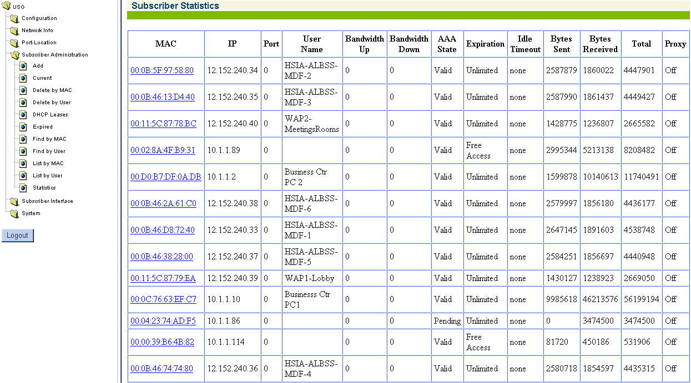

This screen displays the user’s MAC address, IP address, user name etc.

Port – VLAN that the guest is connected to (0 is VLAN1.)
Bandwidth Up/Bandwidth Down – Speed that the guest is able to send and receive traffic (0 is full bandwidth.)
AAA States
Valid – Guest is valid and able to access internet.
Pending – Guest has not signed up for access.
Unknown – Gateway id not sure of their state. Will usually change to Valid or Pending after a few seconds.
Expiration – Tells when the account will expire. Free Access accounts drop automatically when the guest disconnects.
Idle Timeout – Time until connection gets deactivated for being idle.
Proxy – Detects if a proxy is in use by the computer. If set to on and the guest has disabled their proxy server you may need to refresh their account so the proxy flag can be redetected. To do this click on their MAC address and choose Add/Update if they are valid or Delete if they are pending.

Add a User

Sometimes you may need to add a user manually to get them connected. I.E. If the user has a VPN client and has to connect to their VPN before they can get to the internet or some Macintosh PCs require you to manually add them.

Select Subscriber Administration, Current from the left menu. You should receive a screen similar to below:

Find the user’s MAC address or IP address and click on their MAC address. You should get the screen below:
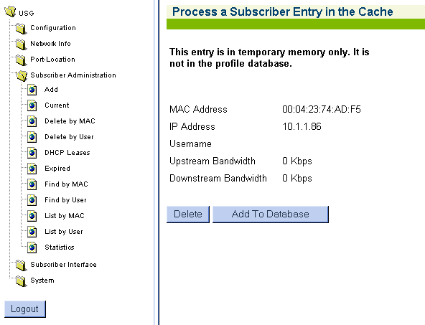

Choose add to database. Copy the MAC address and then choose find by MAC
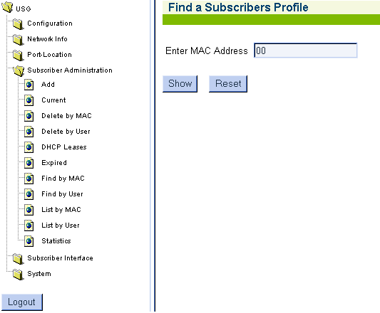

Paste the MAC address and hit show.
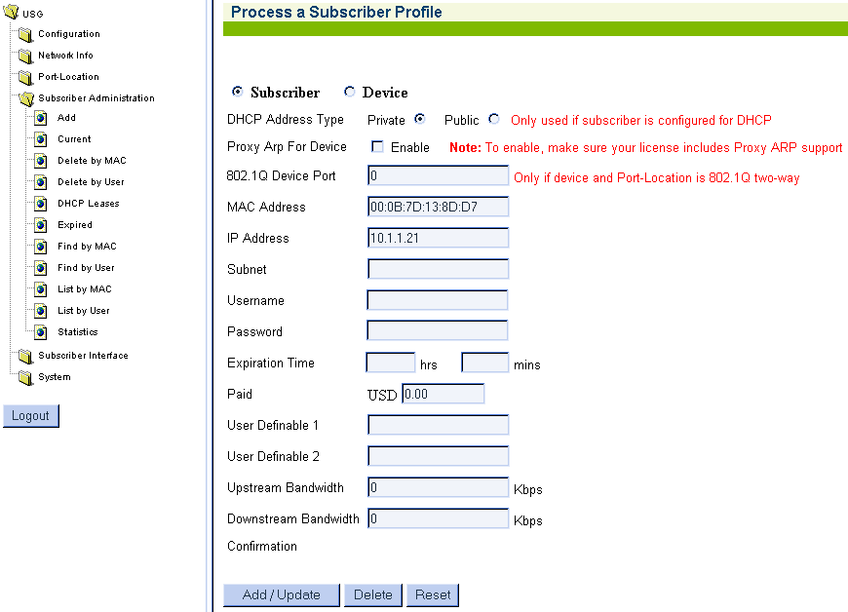

Give the account an expiration time and set the Upstream Bandwidth and Downstream Bandwidth equal to what other guests are getting for the plan at the hotel. The list of current users should show what other guests are getting.
Delete a User Account

This section allows you to delete a user’s account permanently.

Select Subscriber Administration, Current from the left menu. You should receive a screen similar to below:

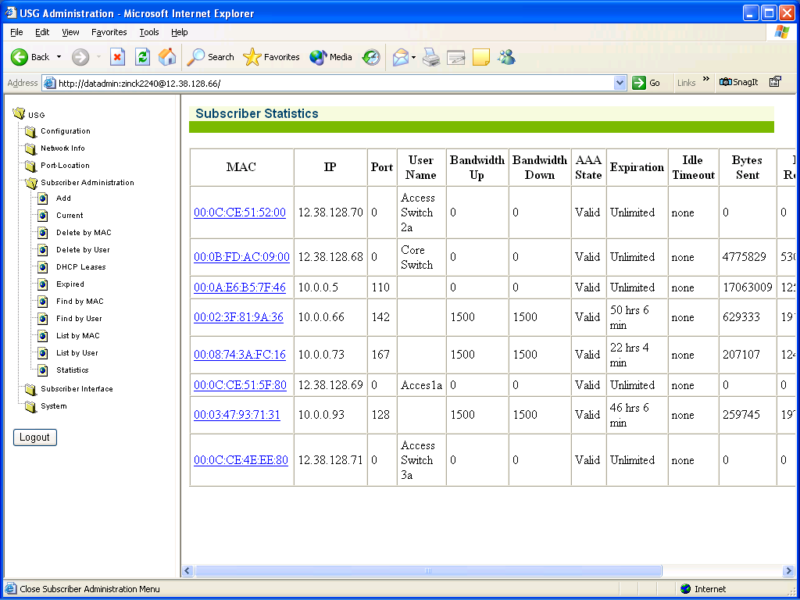

Note: If the user is not listed in this screen, then you can look in Subscriber Administration, List by User. This list displays all users that have active and expired accounts. Select the user’s MAC address and you should receive a screen similar to below:

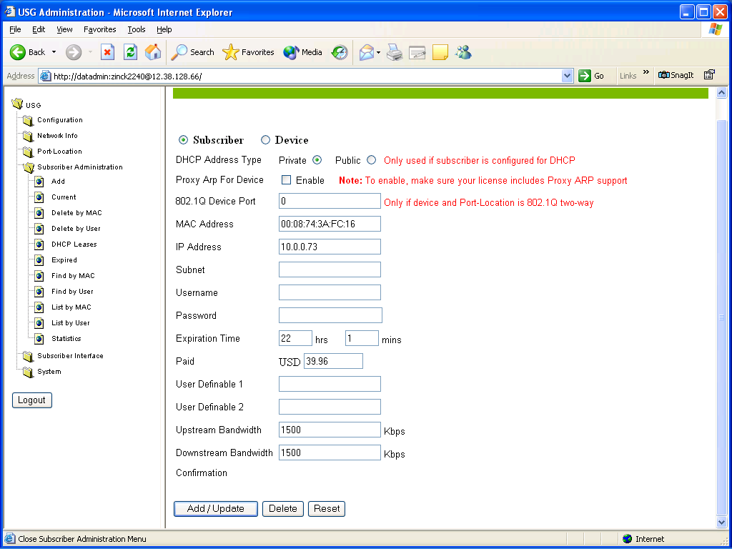

Select Delete.

Find a User or User Name

This section allows you to find a user by MAC address or User Name. It also allows you to List by MAC address or User Name. You can find an XML User Name by selecting the List by User Name.

You can find an XML User Name by selecting Subscriber Administration, List by User. You should receive a screen similar to below:

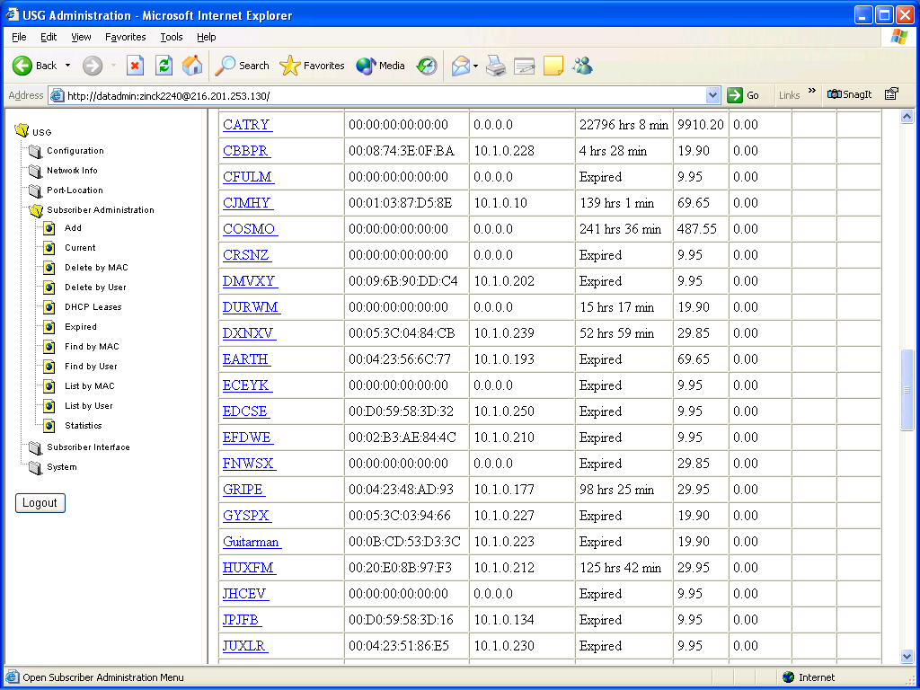

The XML User Names are displayed with the amount of time left for the account. If there is not a MAC address assigned to the User Name, then the User Name was not associated with a PC NIC.

Change a User from a Private IP to a Public IP

This section allows you to switch a DHCP user from a private IP address top a Public IP address.

Select Subscriber Administration, Current. You should receive a screen similar to below:

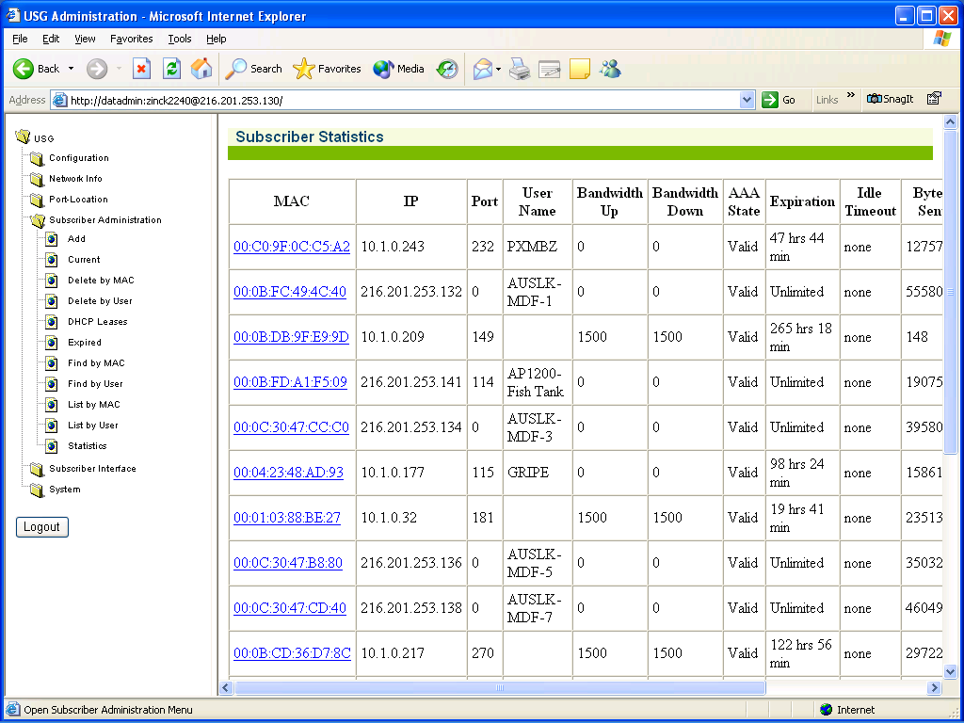

Select the user’s MAC address that you want to change. You should receive a screen similar to below:

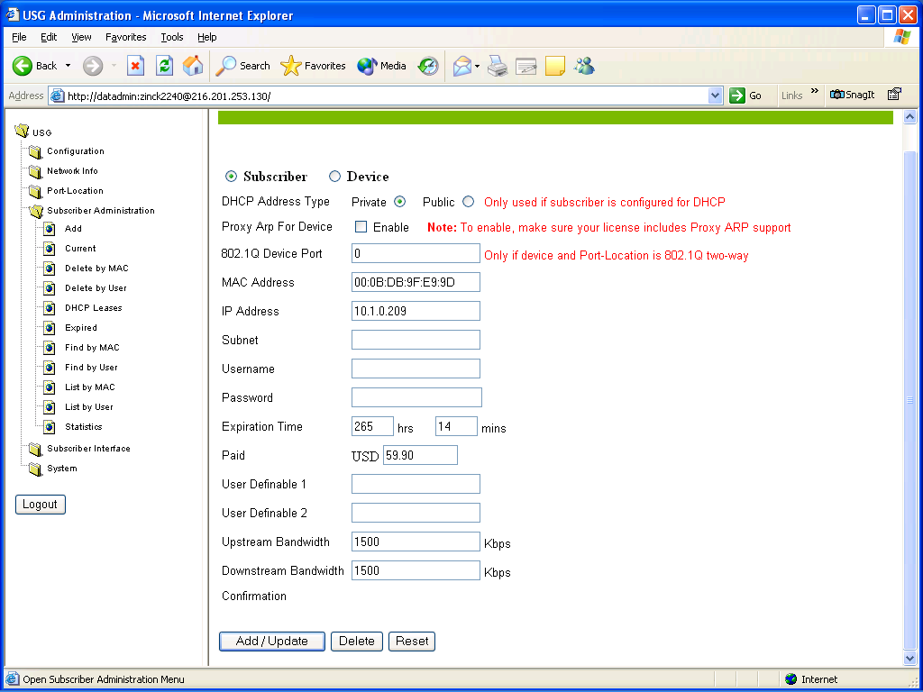

Select the Public billet and then Add/ Update. Have the user reboot their PC or Release and Renew their IP address. They should receive the public IP address.

Note: Contact the property and have them manually bill the guest if the property is billing.

Verify Time Left on a User’s Account

Select Subscriber Administration, List by User from the left menu. You should receive a screen similar to below:

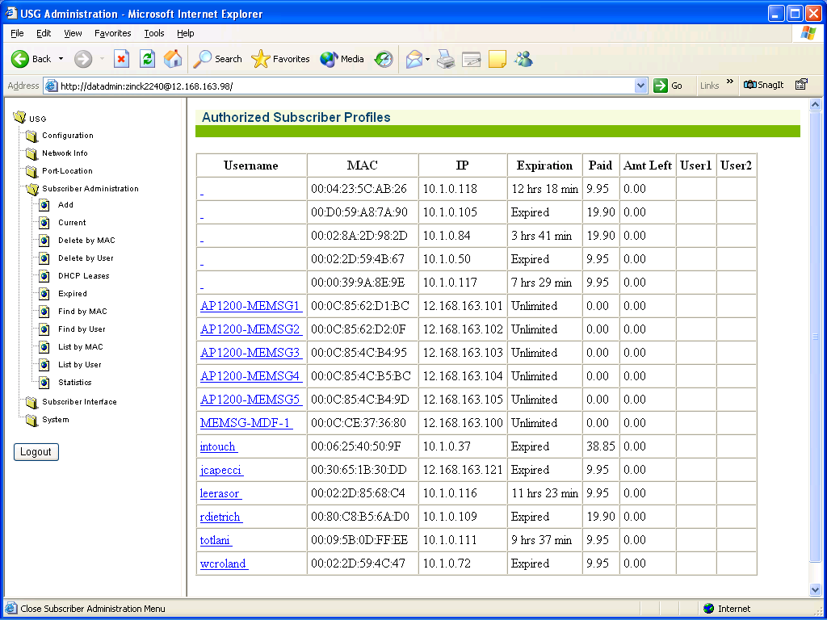

Here you can find the User’s MAC address or User Name and see how much time the guest has left on their account.

Add Time to a User’s Account

Sometimes a user is connected and does not want to loose connectivity when their account expires.

Select Subscriber Administration, List by User from the left menu. You should receive a screen similar to below:

Find the user by MAC address or User Name and click on the User Name. You should receive a screen similar to below:

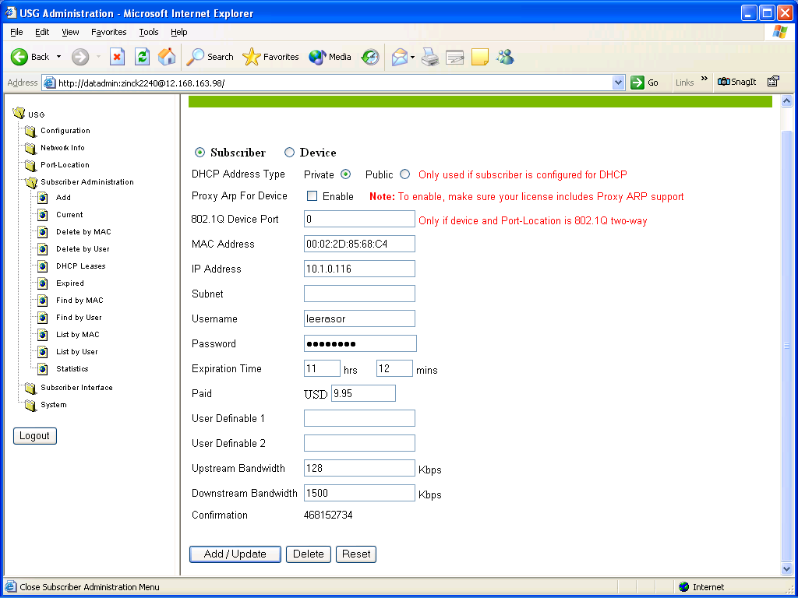

In the Expiration Time field, you can add more time. Remember to look at the Billing Plans (Subscriber Interface, Billing Options) and add the correct amount of time the guest wants to purchase. Contact the front desk and have them post a charge to the user’s account manually. Click submit when done.

User Does Not Get Public IP Address After Purchase

This can happen for a couple of reasons. First, the public DHCP range is full. Second, IP Upsell is not enabled.

DHCP public pool is full

To verify if the public DHCP pool is full, select Configuration, select DHCP. You should receive a screen similar to below.

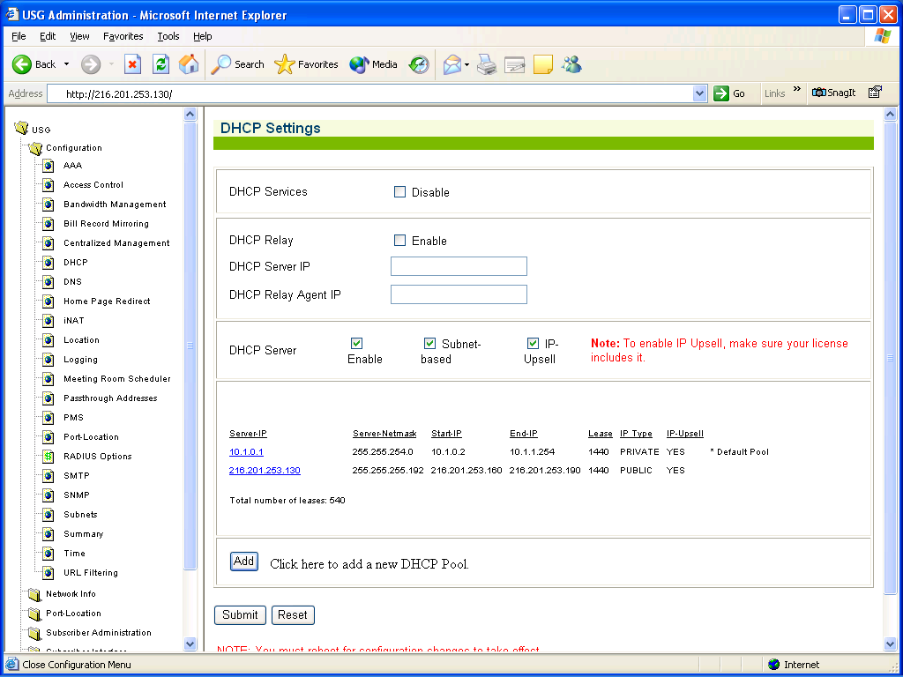

View the Start and End IP range for the public pool. Select Subscriber Administration from the left menu, select List By User. You should receive a screen similar to below:

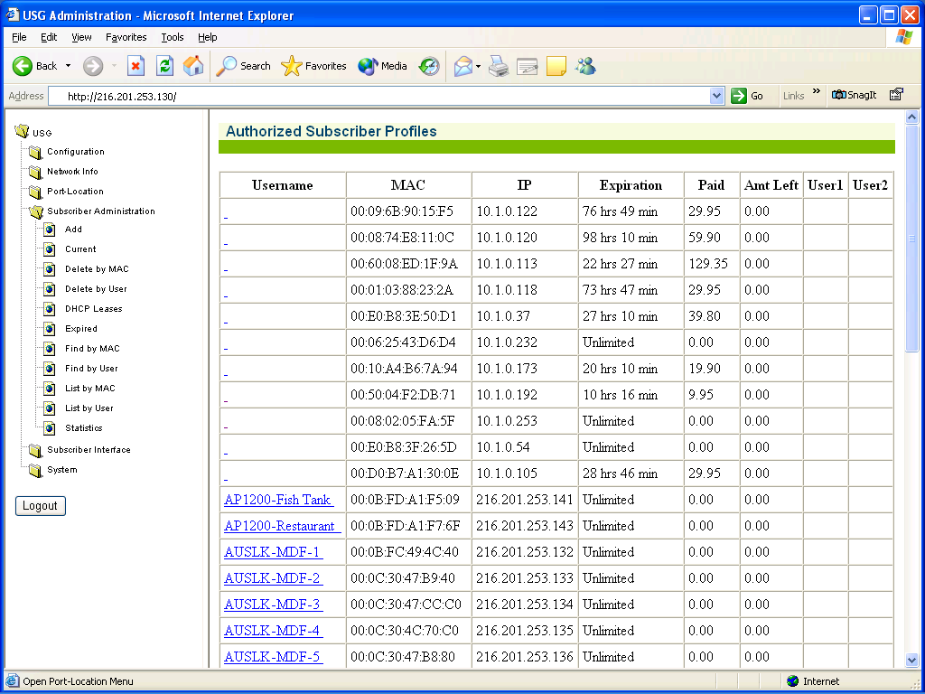

Look in the list of users and see if all the public IP addresses are assigned. If the public DHCP range is full, there is nothing we can do for the guest. The guest will have to wait until an address is available.

IP Upsell

To verify if IP Upsell is enabled, select Configuration, DHCP. You should receive a screen similar to below:

There should be a check in the box next to IP-Upsell. If there is not, check the box (make sure that AAA is enabled. Configuration, AAA, AAA services) and reboot the USG. The user should receive a public IP address now.

Configuration

This is where most of the USG configuration is done. This is done by the installer and should not have to be modified.

Verify If the USG Has SMTP Redirection

After connecting to the USG via web browser, select Configuration. Under configuration, select SMTP. You should receive a screen similar to below:

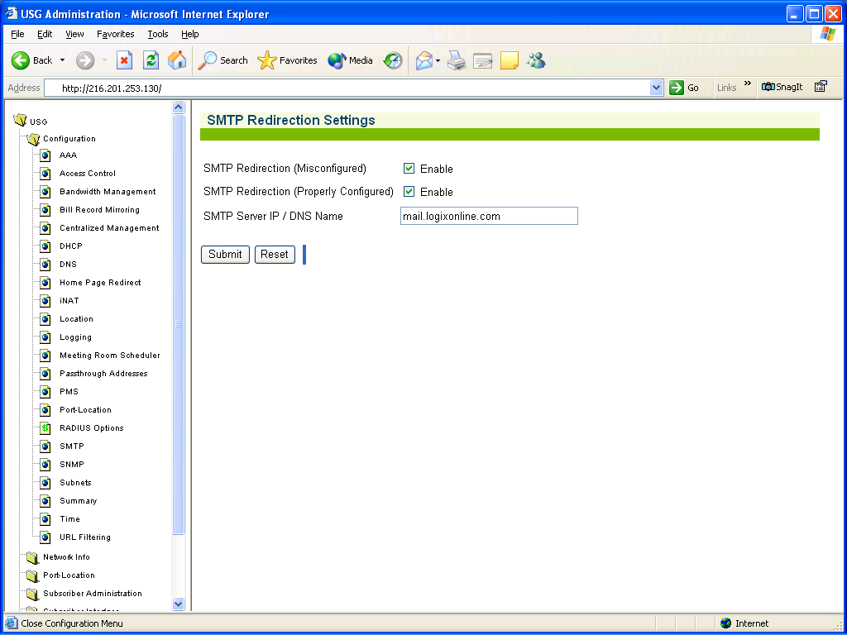

This USG is setup for SMTP redirection. If the SMTP Server IP / DNS Name is blank, then the property does not have a redirection server.

To add a redirection server, simply check both boxes and add the redirection server IP address or DNS name in the SMTP Server IP/ DNS Name filed.

Homepage Redirection

Homepage redirection sends the user’s browser to the URL that is setup in the homepage redirect field after the user first logs on and has been authenticated by the USG.

To change or view the Homepage Redirect, from the left menu, select Configuration, Homepage Redirect.

You should receive a screen similar to below:
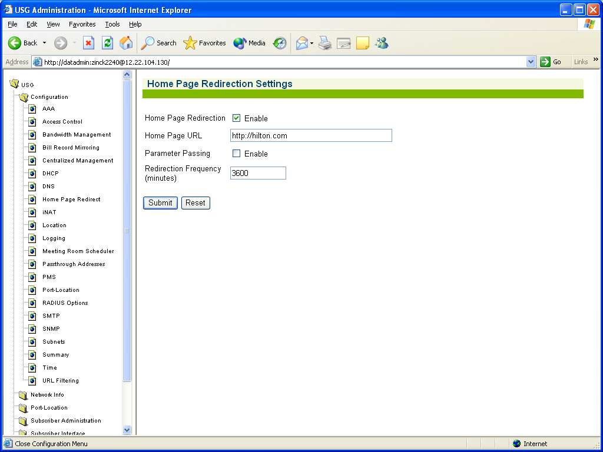

If you modify the Home Page URL, remember to select Submit.

Pass Through Addresses

This feature allows users to go to websites without having to purchase internet access.

To view or add a pass through address, from the left menu, select Configuration, Passthrough Addresses.

You should receive a screen similar to below:

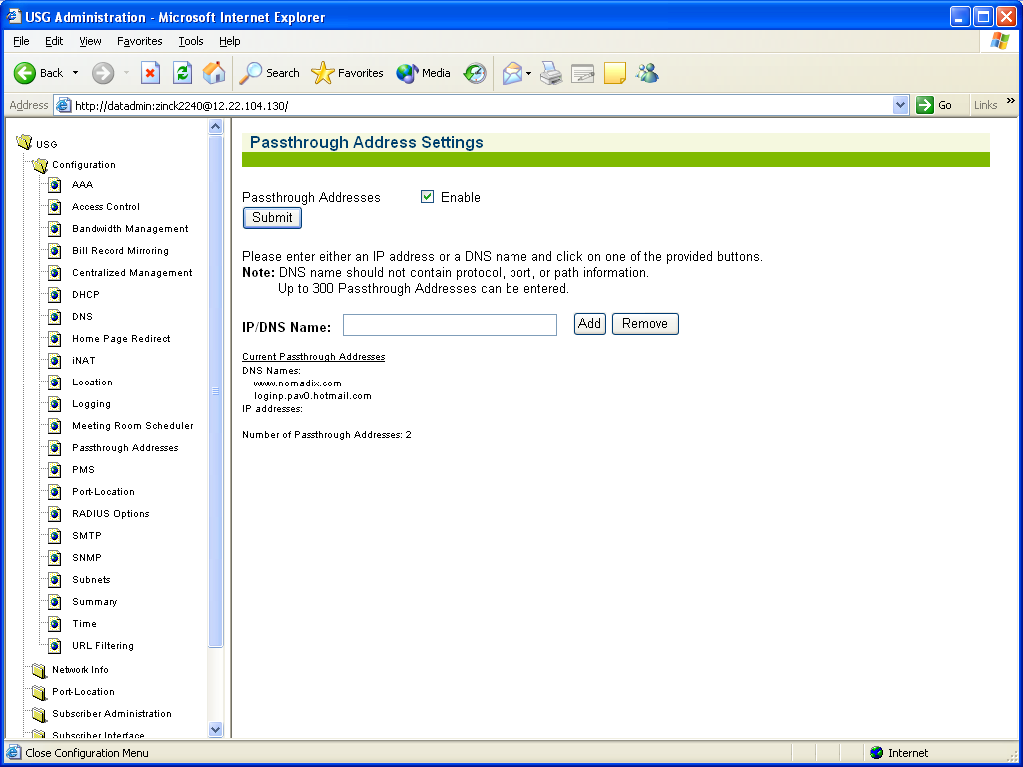

To add a new URL, add the IP or DNS name in the IP/DNS Name field and select Add. Remember to get approval from the property to do this.

Port Location

This section is where you can add, delete, modify and view a port.

Change the Status of a Port

To change the status of a port, select Port Location, List from the left menu. You should receive a screen similar to below.

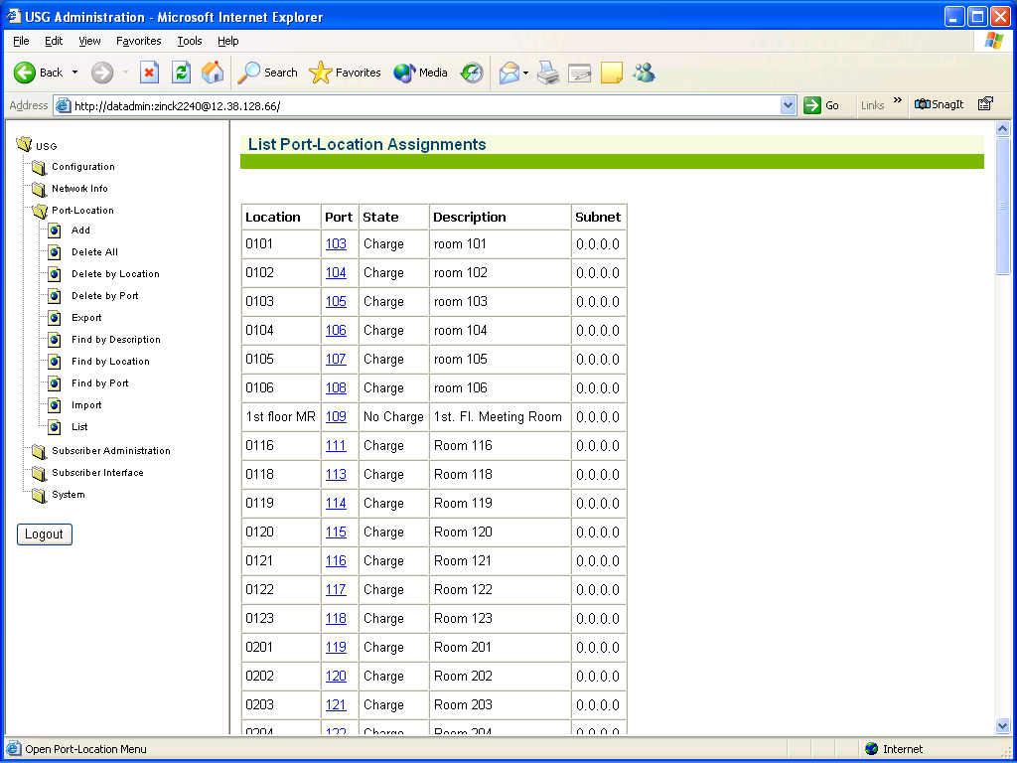

Select the port you want to change. You should receive a screen similar to below:

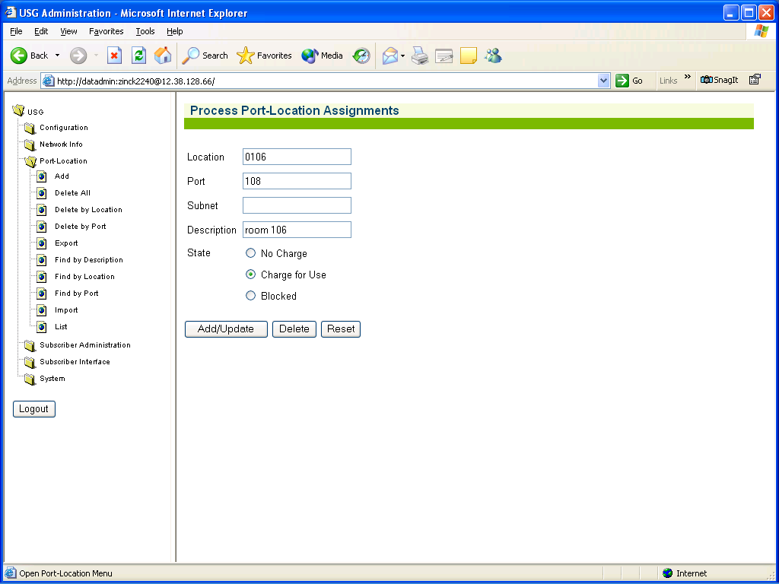

Select Add/Update after you select the correct State.

Find a Port Mapping

You can find a port mapping by port, location, description or in the list if you know what you are looking for. All these options are located by selecting Port Location from the left menu. An example is searching by port number 106. You should receive a similar screen to below:

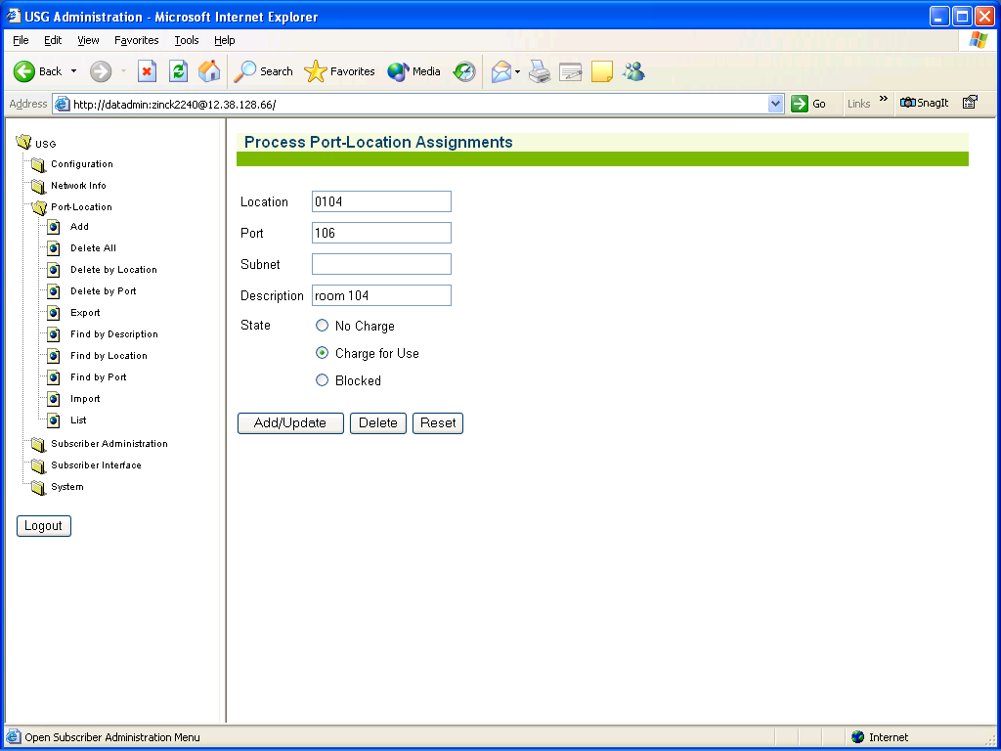

From here you can change the Location, Port, Subnet, Description and State of the room.

Error Messages

This section covers the most frequent error messages that occur.

This Field Must Contain a Number Between These Two Values; ; 1,1

This error message means that the property is setup to only allow one day of internet access at a time. The user needs to enter the number 1 for days to purchase.

The Promotional Code You Have Entered is not Correct. Please Try Again.

This means that the user entered a promotional code when signing up for internet access and the code was entered incorrectly or the code is invalid.

USG Blocked Subscriber Access

This means that the port the user has connected to is set to blocked. This could be because the property has a meeting room scheduler and has not opened the port or the port is just blocked. Send to 2nd level engineer.

The User ID You Have Entered Cannot be Found. Please Try Another.

This means that the user name the user entered is invalid or does not exist. You can remove the user’s ID by selecting Subscriber Administration, Current. Find the user’s MAC address in the list and click on the MAC address. In the Username field, you can remove the username or change it. Click Add/Update when done.

The Password Field You Have Entered Is Not Correct. Please Try Another.

This means that the password the user entered is invalid or does not exist. You can remove the user’s password by selecting Subscriber Administration, Current. Find the user’s MAC address in the list and click on the MAC address. In the Password field, you can remove the password or change it. Click Add/Update when done.

Error in Room Billing

This means that the user has either hit the submit button more than once while signing up or the port is not mapped.

First have the user close their browser and reopen it to see if they can get to the internet.

To verify if the port is mapped, select Port Location, List from the left menu. If the port is not listed, then you will have to add the port. See Add a Port section.

Portal Screens

Free Access

When the guest opens their browser, they will be redirected to the following screen:

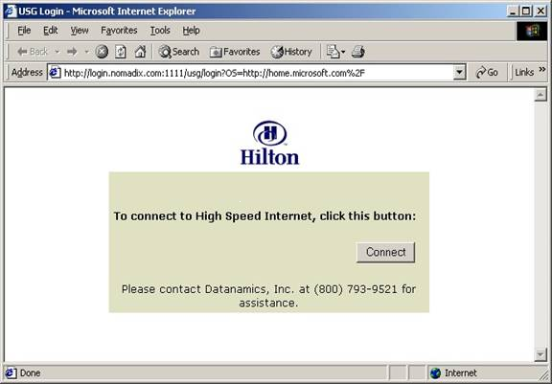

After the user selects connect, the will receive the following screen:

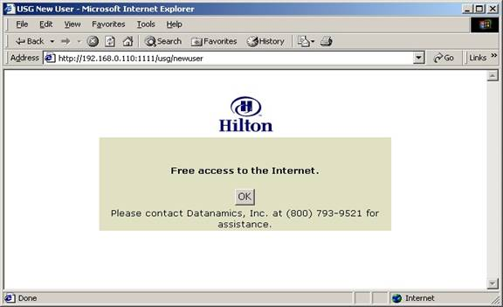

After the user selects OK, they will be redirected to which ever Homepage Redirect is setup.

Wired with Access Codes – Billing

After the user opens their browser, they will receive a similar screen to below:

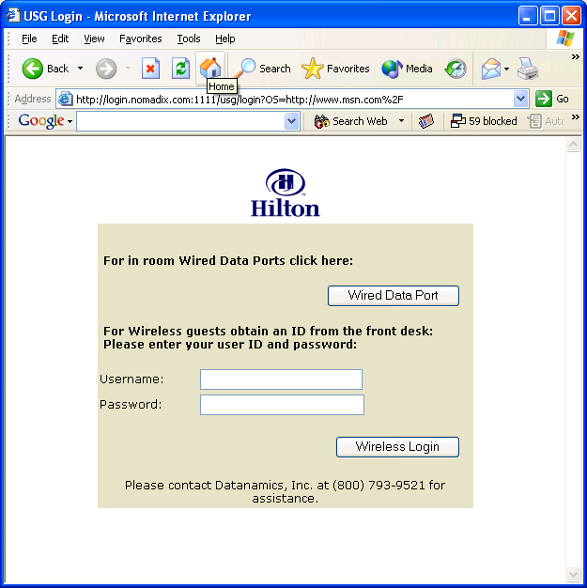

If the user has a Username and Password, they will enter it here. If they are a wireless user, and they do not have a Username and Password, they will need to obtain one from the property.

If they are a wired user, then the user will select Wired Data Port. The user should receive a screen similar to below:

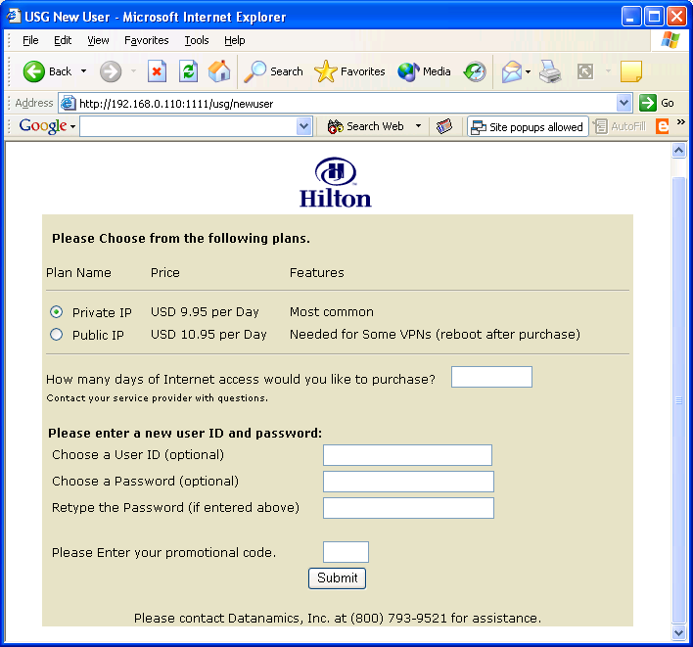

Note: Plans will vary from property to property.

Here, the user will select the plan of choice and how many days they would like to purchase. They can create a Username and Password to be used later if they decide to use wireless access. They will enter a promotional code if they have on and select submit. After the user selects submit, they will receive a screen similar to below:

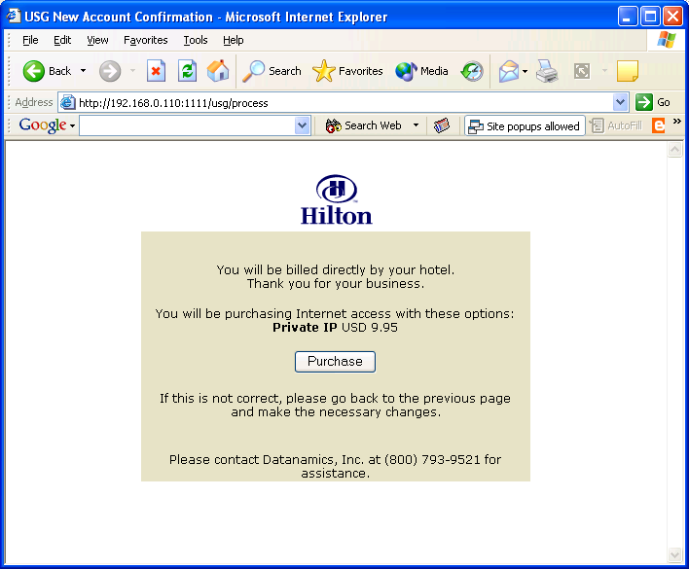

After the user selects the Purchase screen, they will be redirected to the Homepage Redirect URL that is setup.

Wireless Only – Billing

After the user opens their browser, they will receive a similar screen to below:

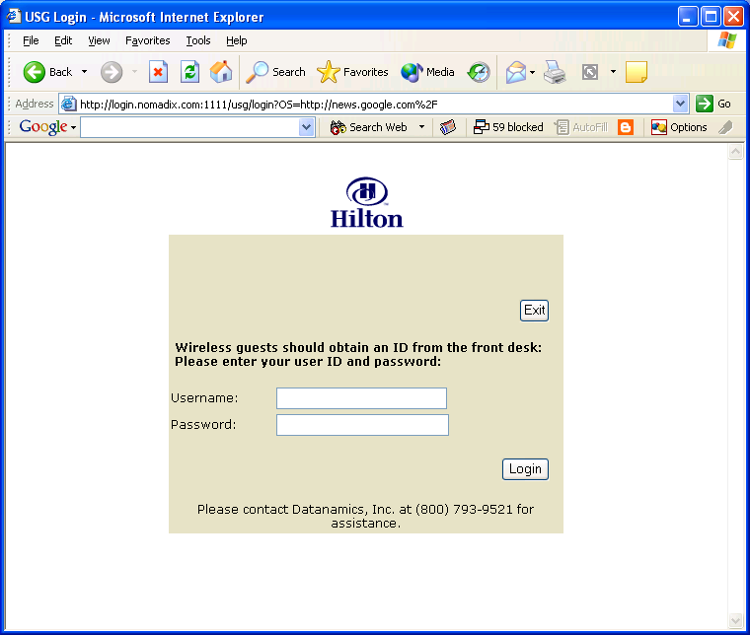

The user needs to enter their Username and Password. If they do not have a Username and password, they will need to contact the property to obtain one.

After the user selects Login, they will be redirected to the Homepage Redirect URL that is setup.

If the user enters an invalid Username or Password, they will receive a screen similar to below:
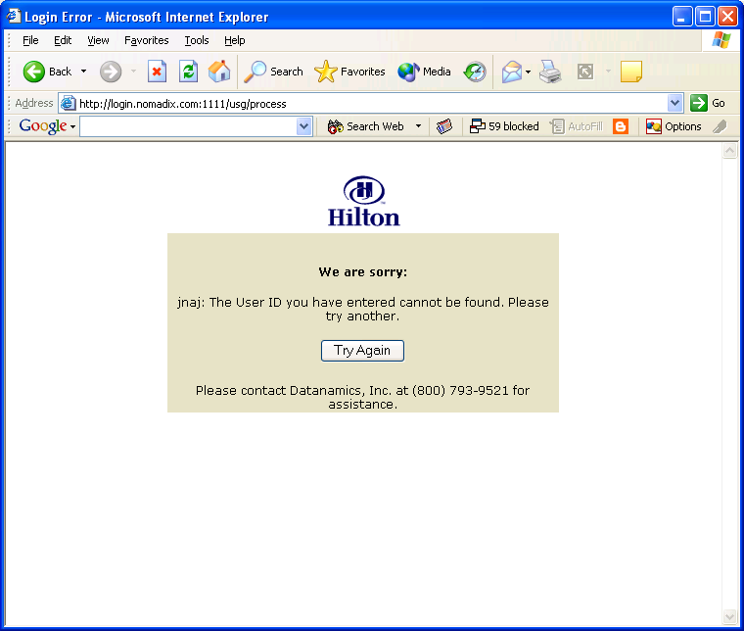

Credit Card – Billing

After the user opens their browser, they will receive a similar screen to below:

After the user selects Wired Data Port, they will receive a screen similar to below:
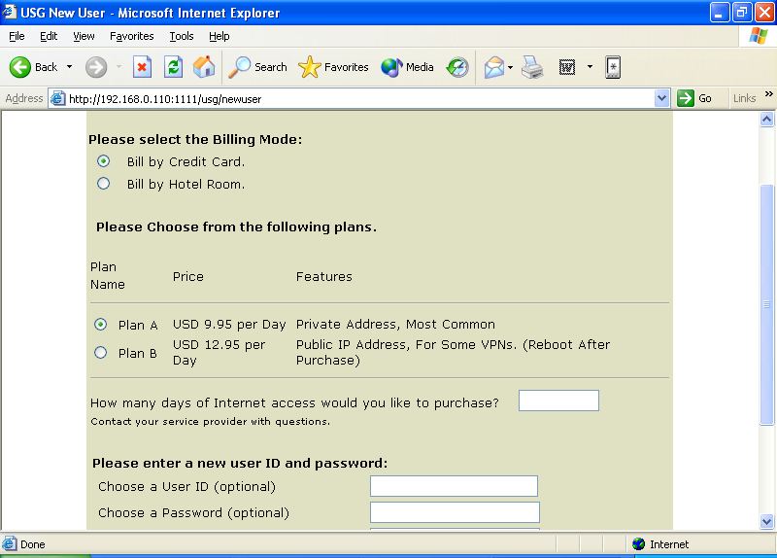

They will select the Credit Card billet.

Note: Plans will vary from property to property.

Here, the user will select the plan of choice and how many days they would like to purchase. They can create a Username and Password to be used later if they decide to use wireless access. They will enter a promotional code if they have on and select submit. After the user selects submit, they will receive a screen similar to below:

After the user selects Purchase, they will be redirected to Authorize.net and receive a similar screen to below where the user will need to provide all information that is tied to the user’s credit card. After the user submits the information, they will be redirected to the Homepage Redirect URL that is setup.

